
Agenda
What is Spark
Spark Architecture
Spark Benefits
Lazy Evolution
Jobs,Stages and Tasks
Databricks Free account
Spark Language Options
PySpark Coding – The Real OG

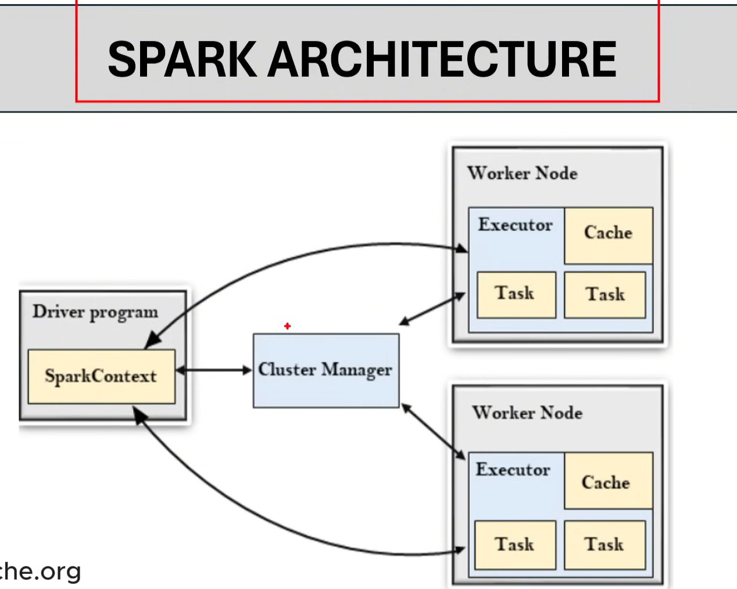
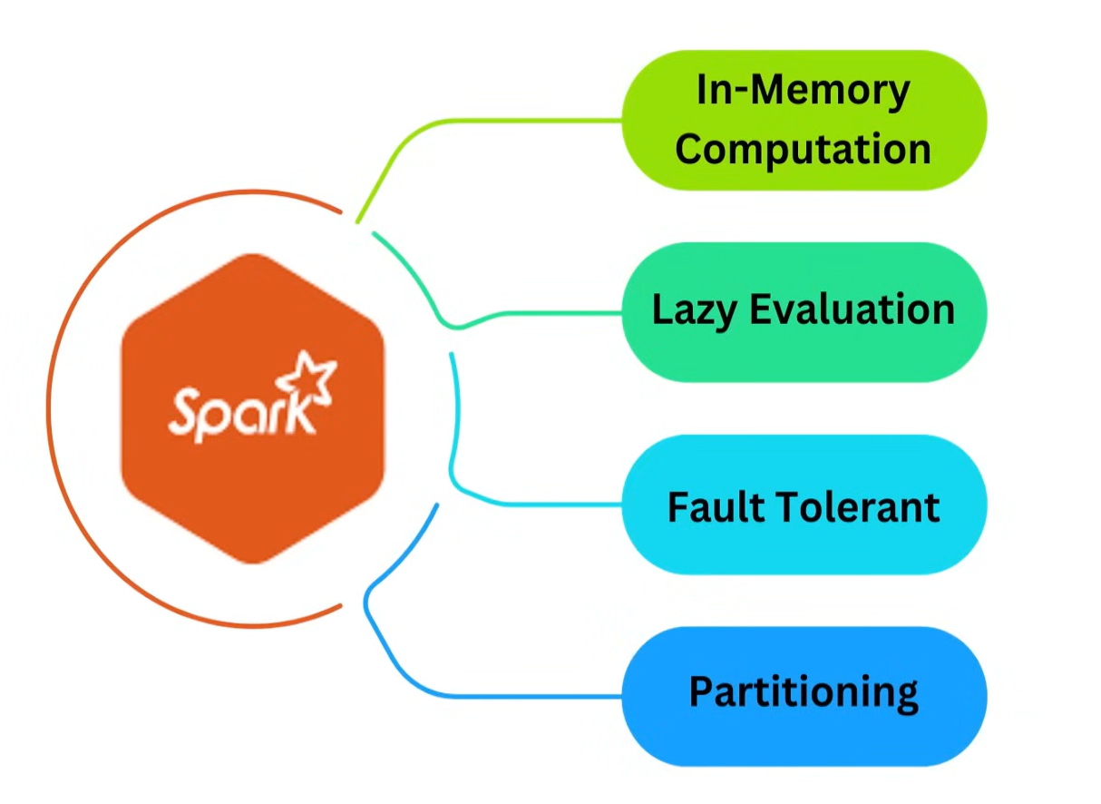
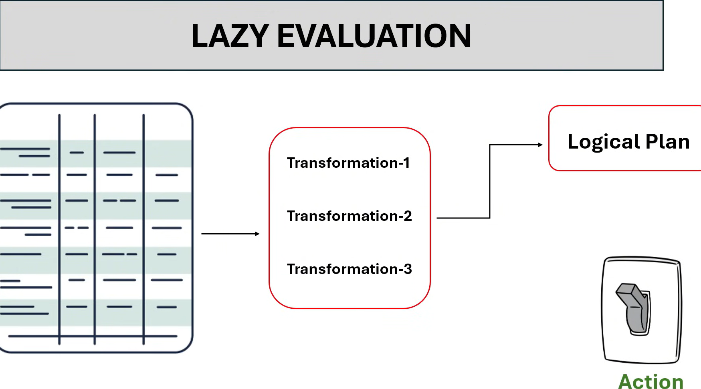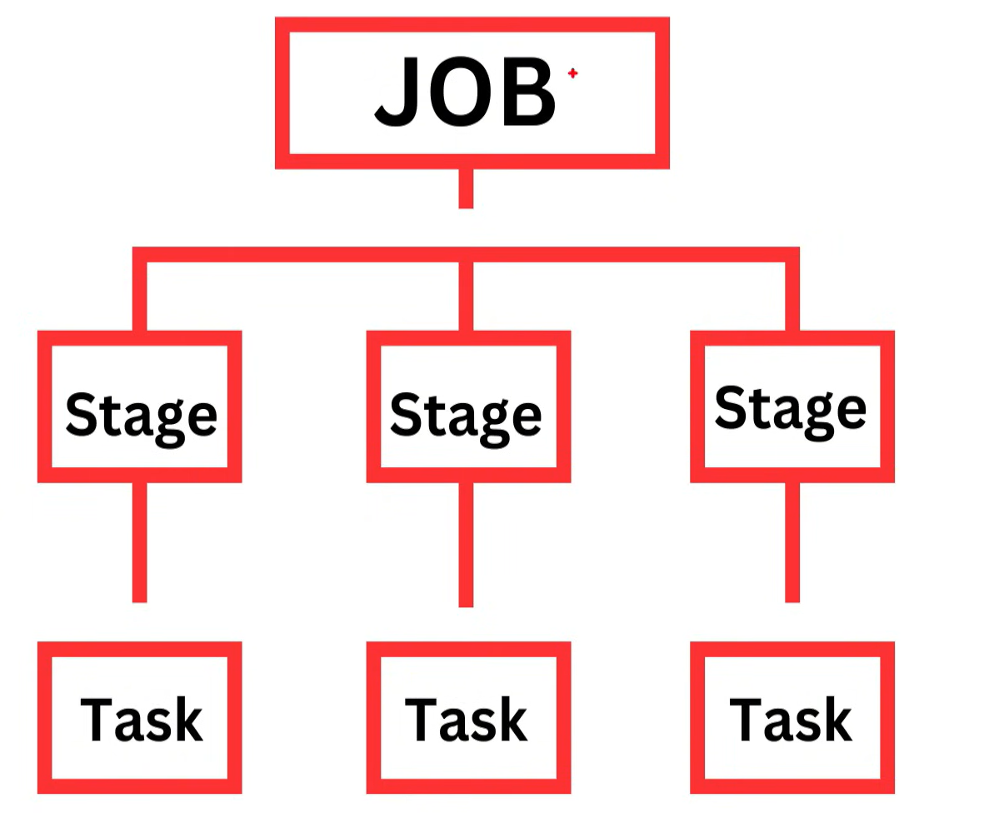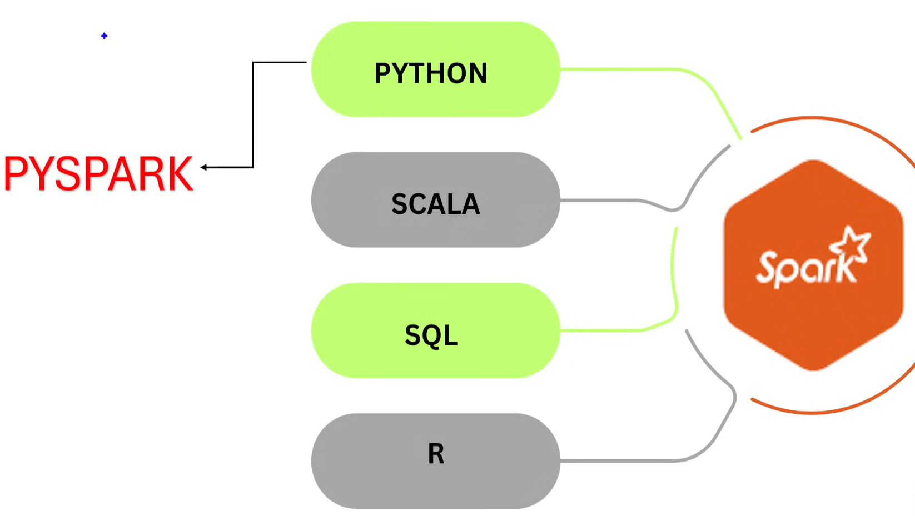

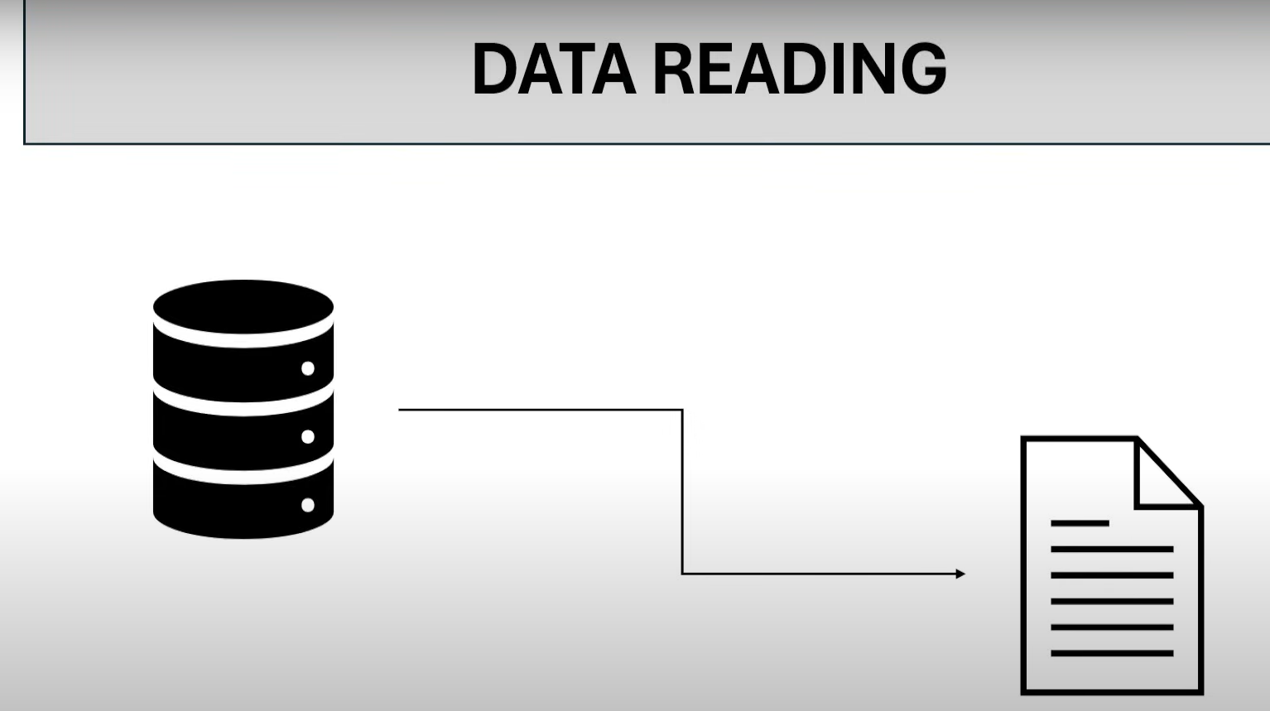
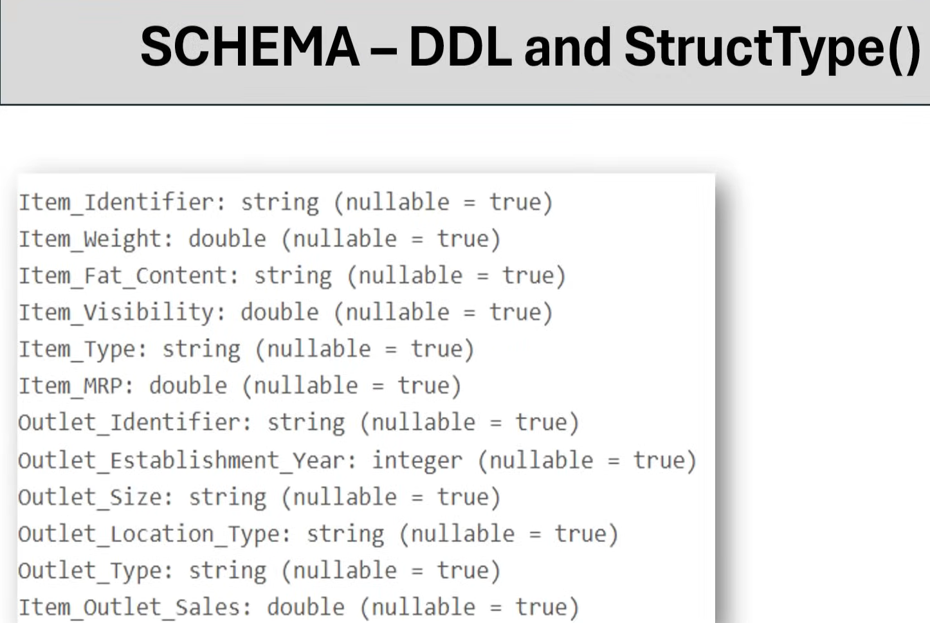
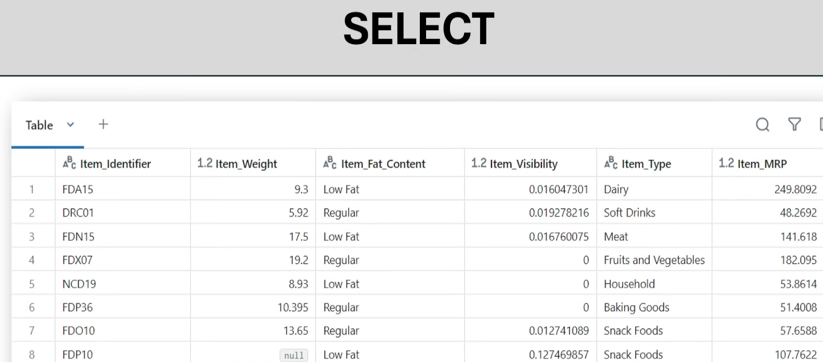
After this 1)Select
2)Col
3)Alias
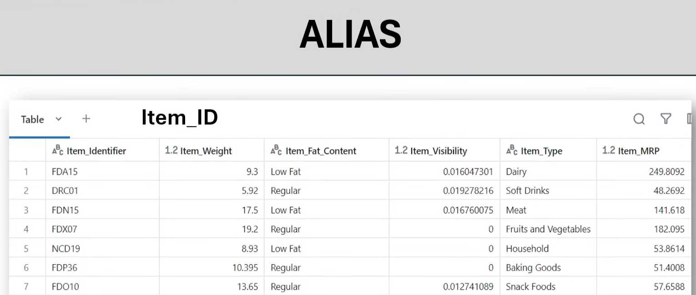
Df.select(col(‘Item_Identifier’).alias(“Item_id”)).display()

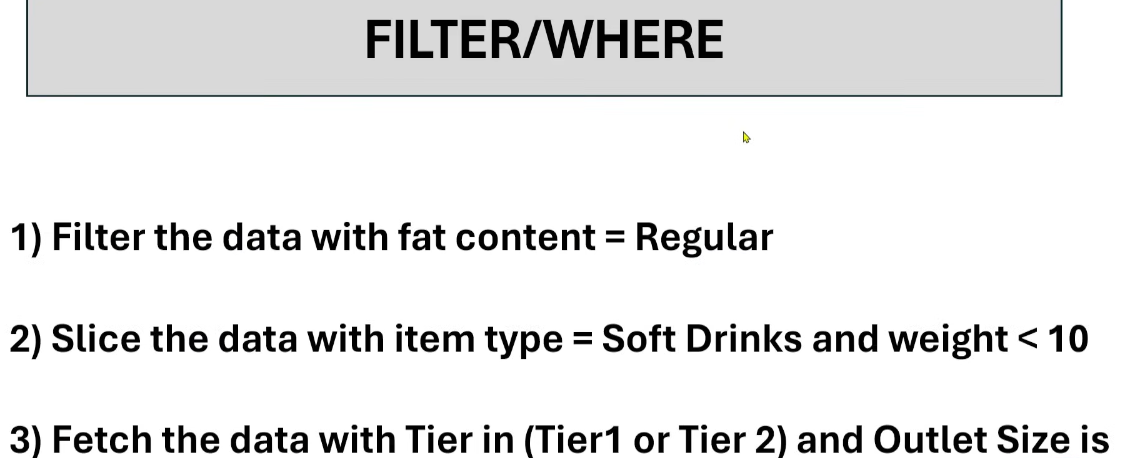


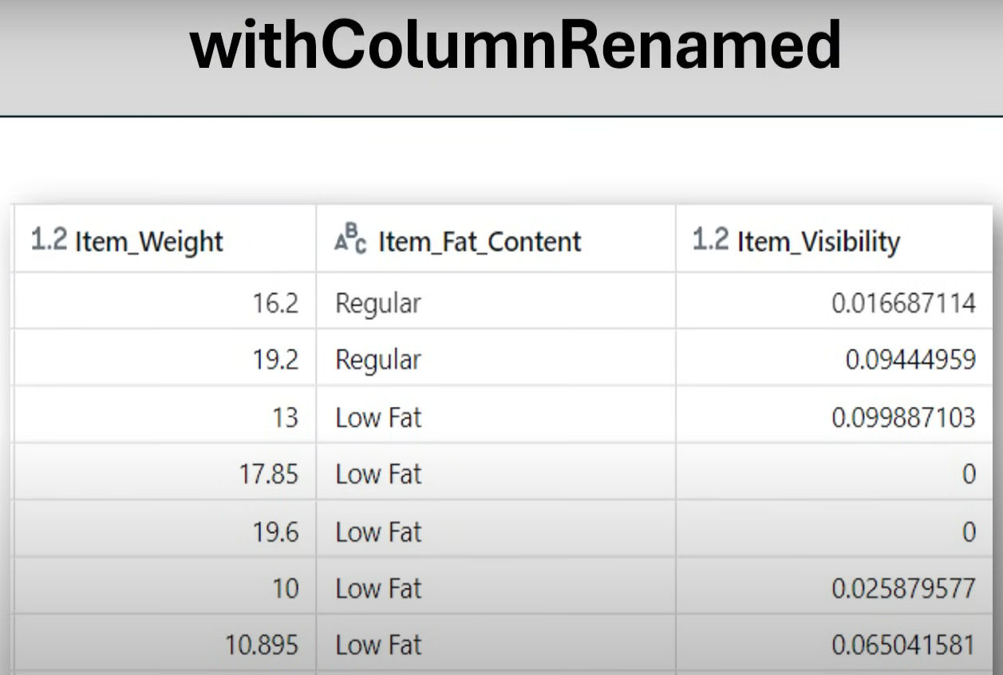

Df.witcolumnrenamed(‘Item_weight’,’Item_wt’).display()
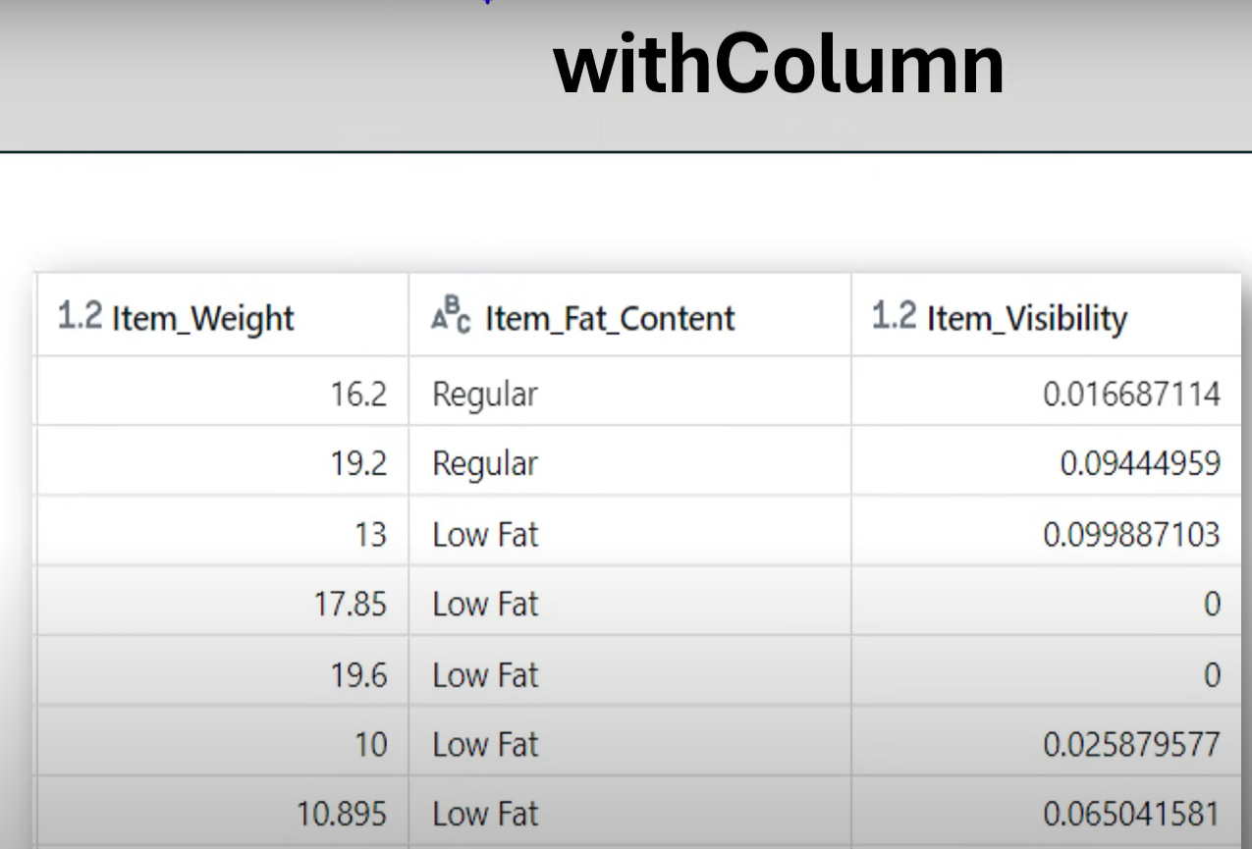
Df.withcolumn(‘flag’,lit(‘new’)).display();
Df.withcolumn(‘multiply’,col(‘item_weight’)*col(‘item_mrp’)).display();
Df.withcolumn(‘item_fat_content’,regexp_replace(col(‘Item_fat_content’,”Regular”,”Reg”))).display();
withColumn: it is used to create a new column and used to update the existing values in the columns
Scenario1: create a new column with name flag and the constant value true
Scenario 2: multiply item_weight and item_mrp
Scenario 3: item fat content Low fat as LF and Regular as Reg

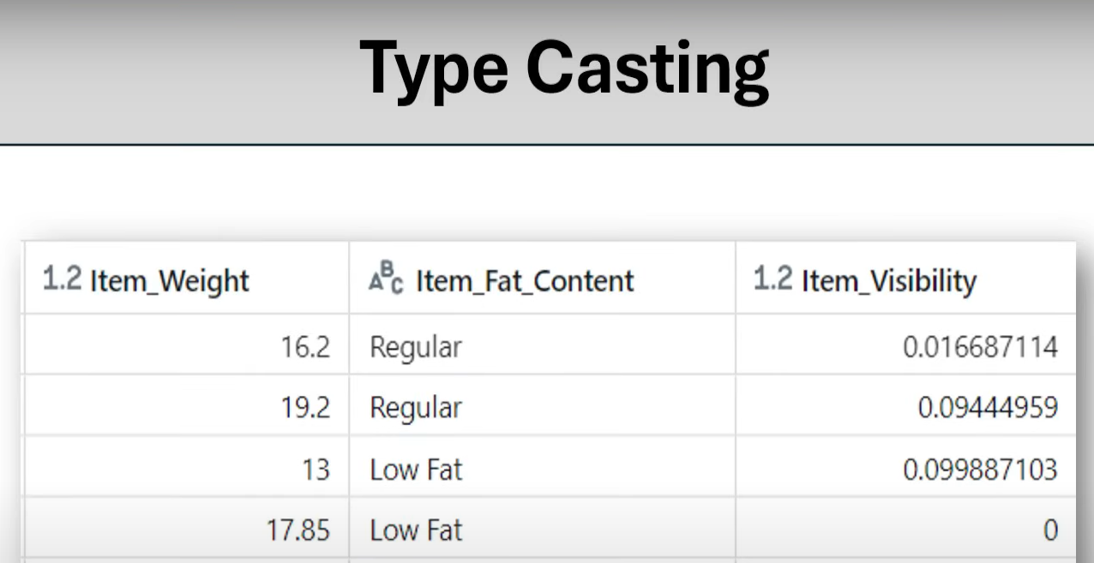
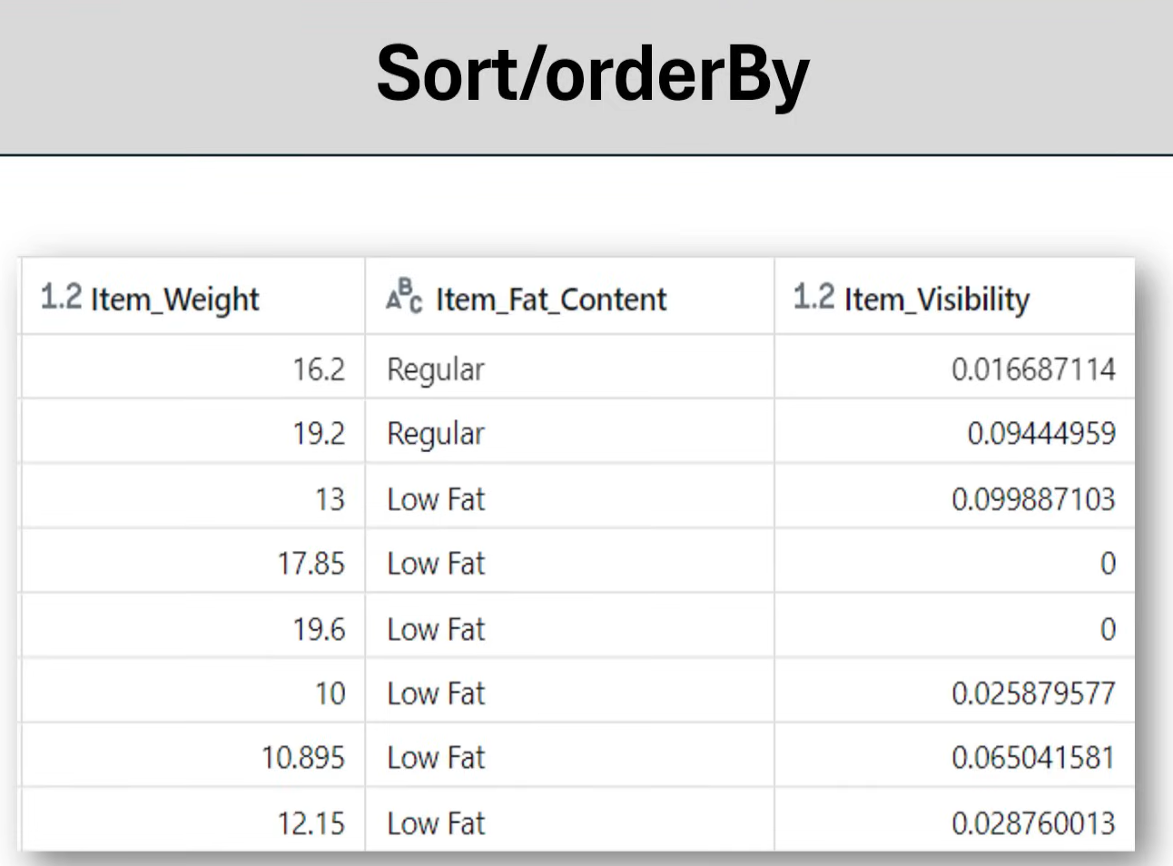
Scenario 1: Sort the column Item_weight in descending order
Scenario 2: Sort the column Item_visibility in ascending order
Scenario 3: Sort the columns Item_weight and Item_visibility in descending order
Scenario 4: Sort the columns Item_weight n descending order and Item_visibility in ascending order

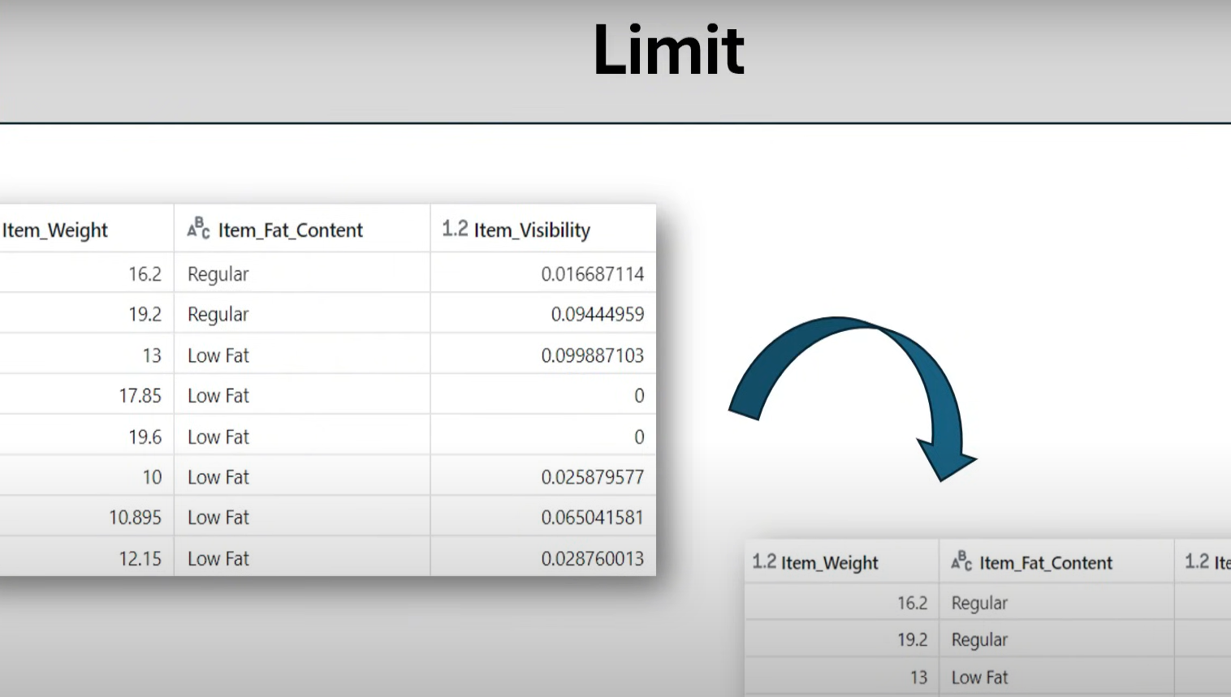

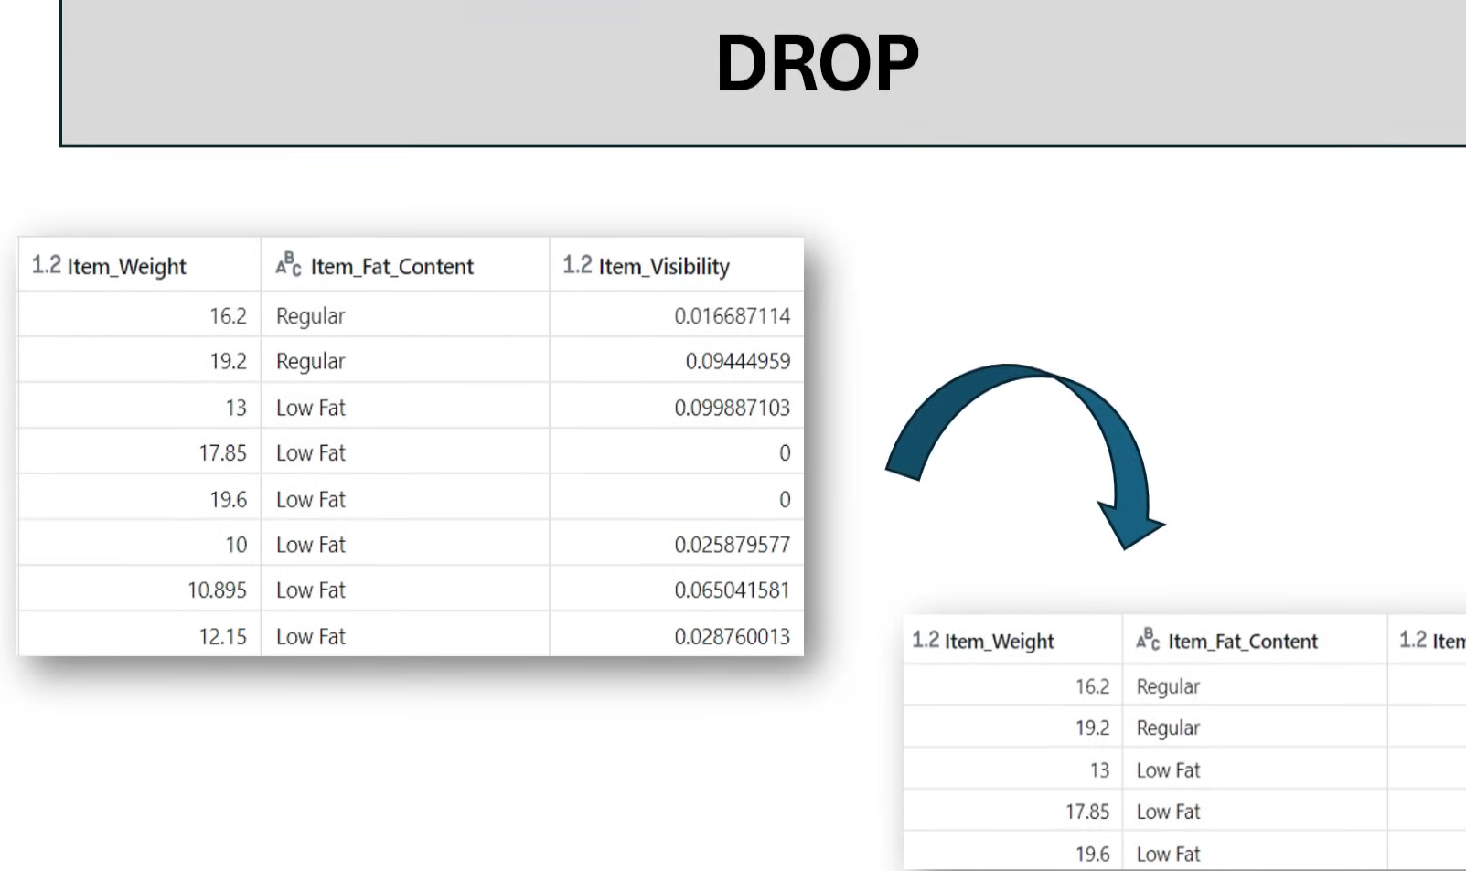

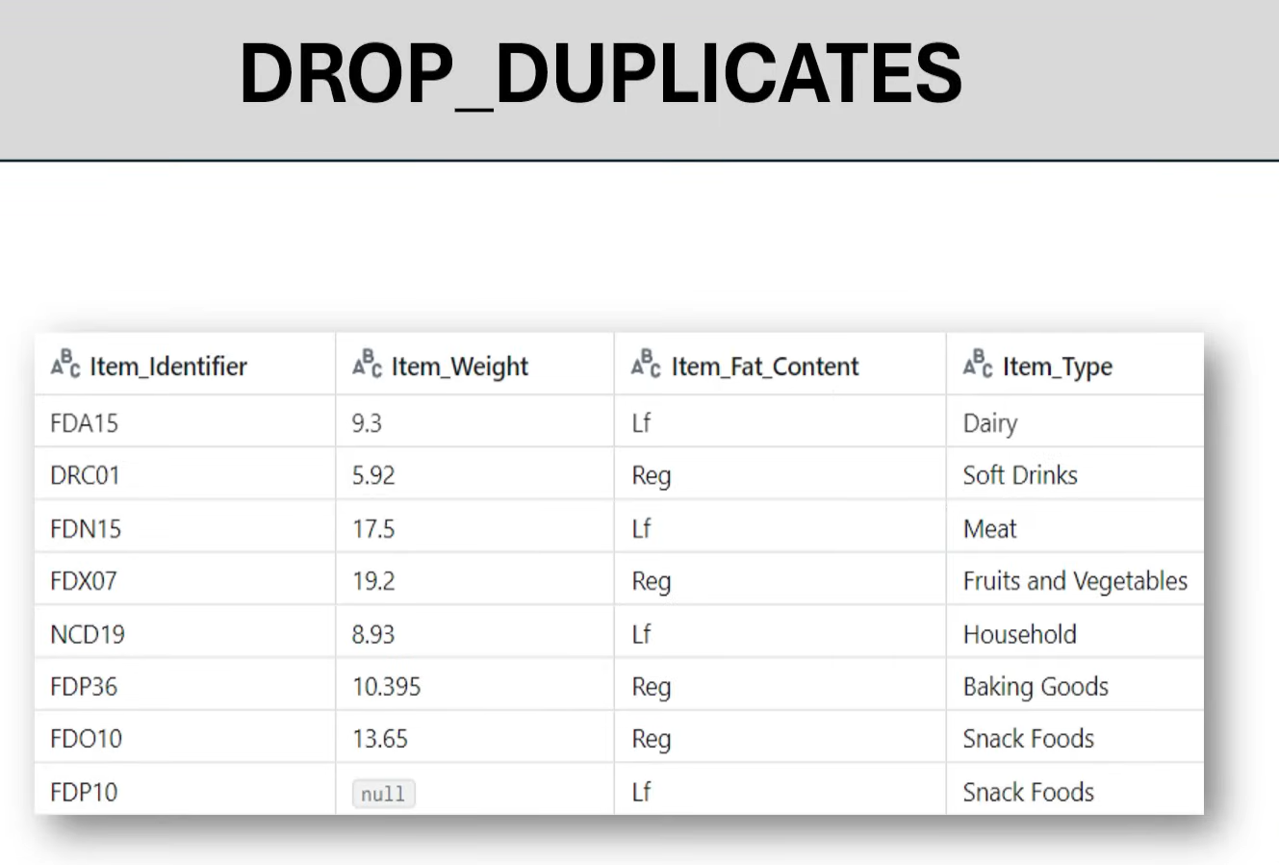
Scenario 1: drop duplicates
Scenario 2: drop duplicates for aprticular column Item type subset=
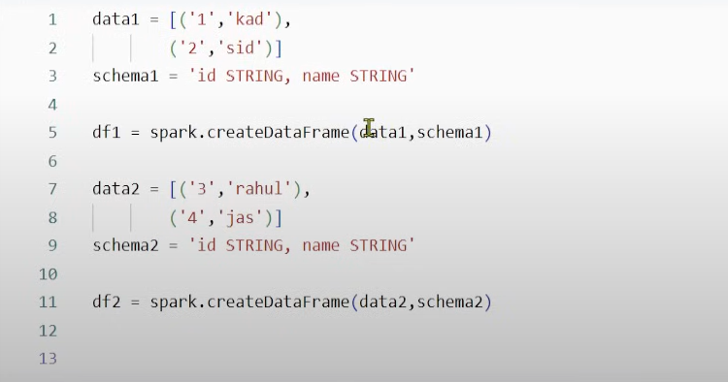
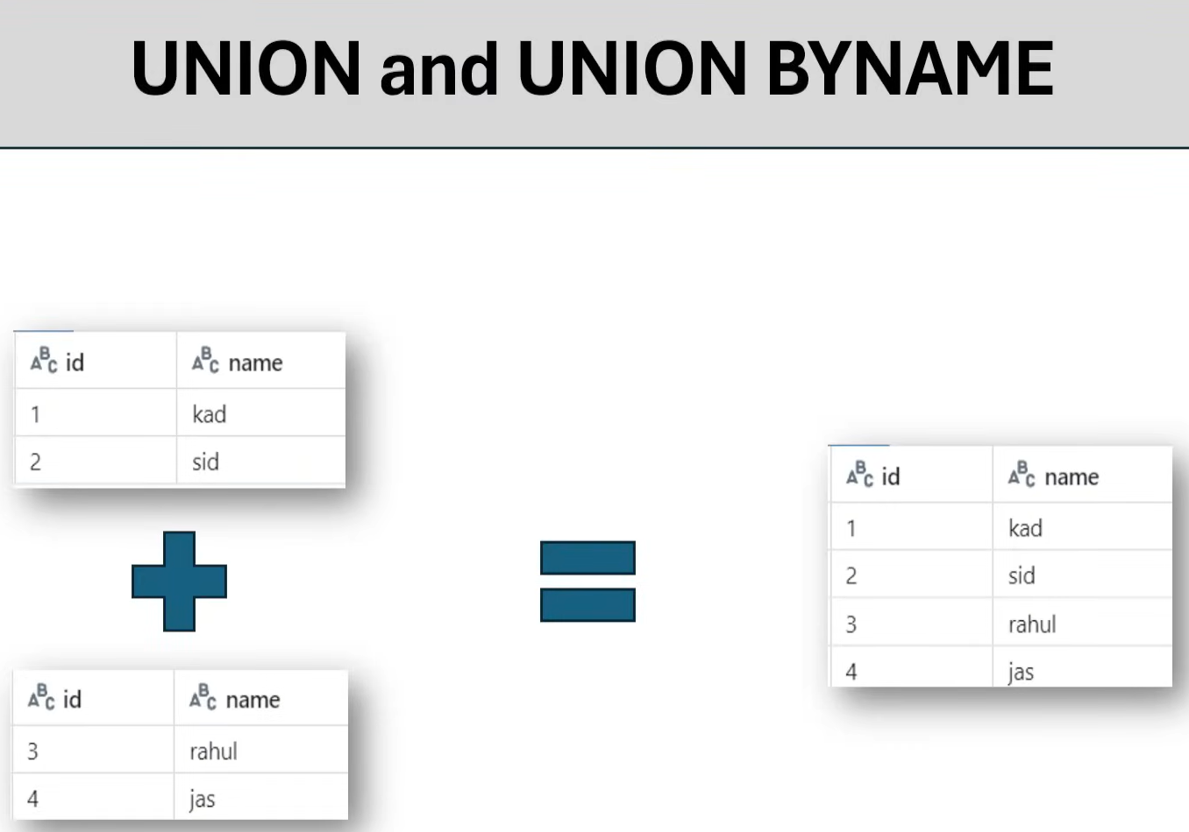
Df1.union(df2).display()
Df1.unionbyname(df2).display()

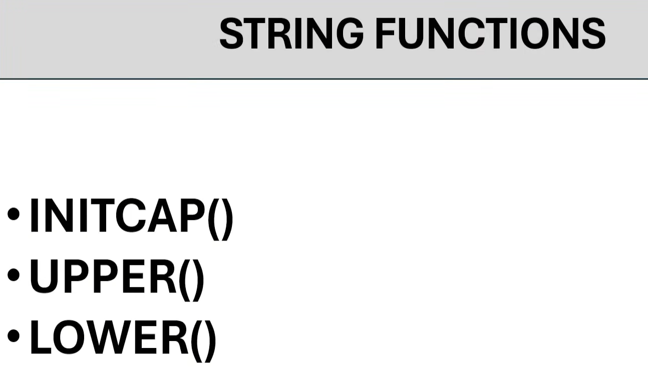
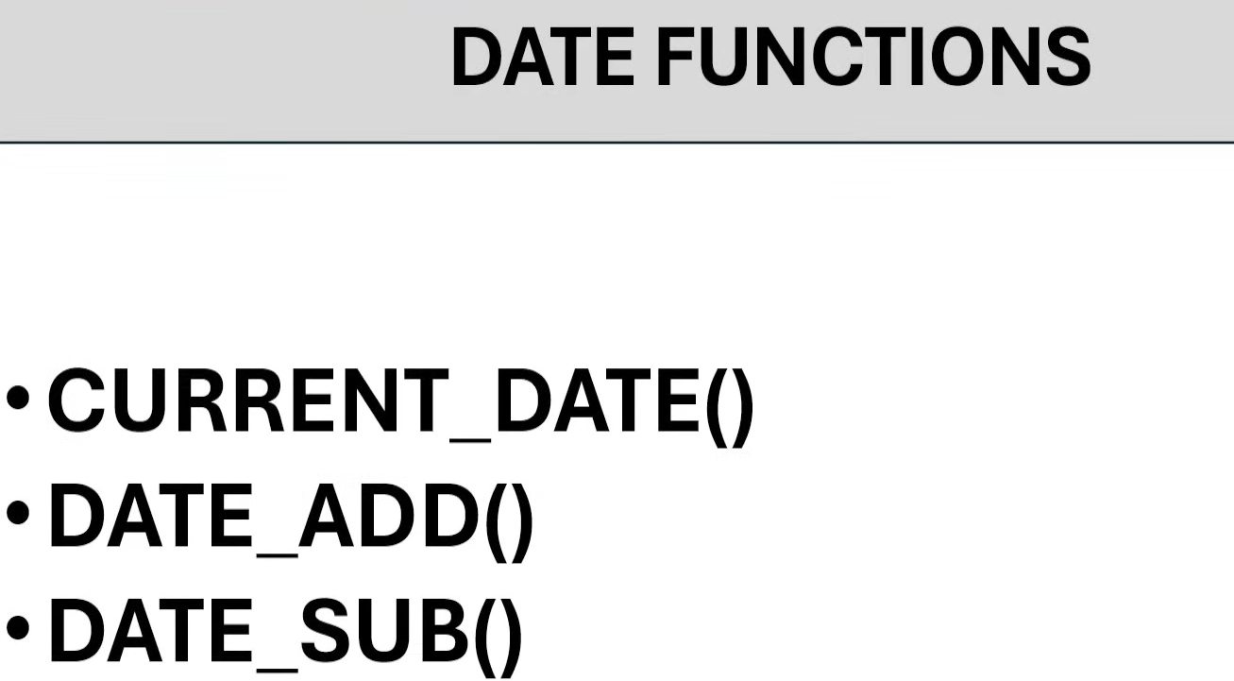
Df_curr = df.withcolumn(‘curr_date’,current_date())
Df_curr.display()
Df_add = df_curr.withcolumn(‘weef_after_date’,date_add(‘curr_date’,7))
Df_add.display()
Date_sub = Df_add.withcolumn(‘week_before_date’,date_sub(‘curr_date’,7))
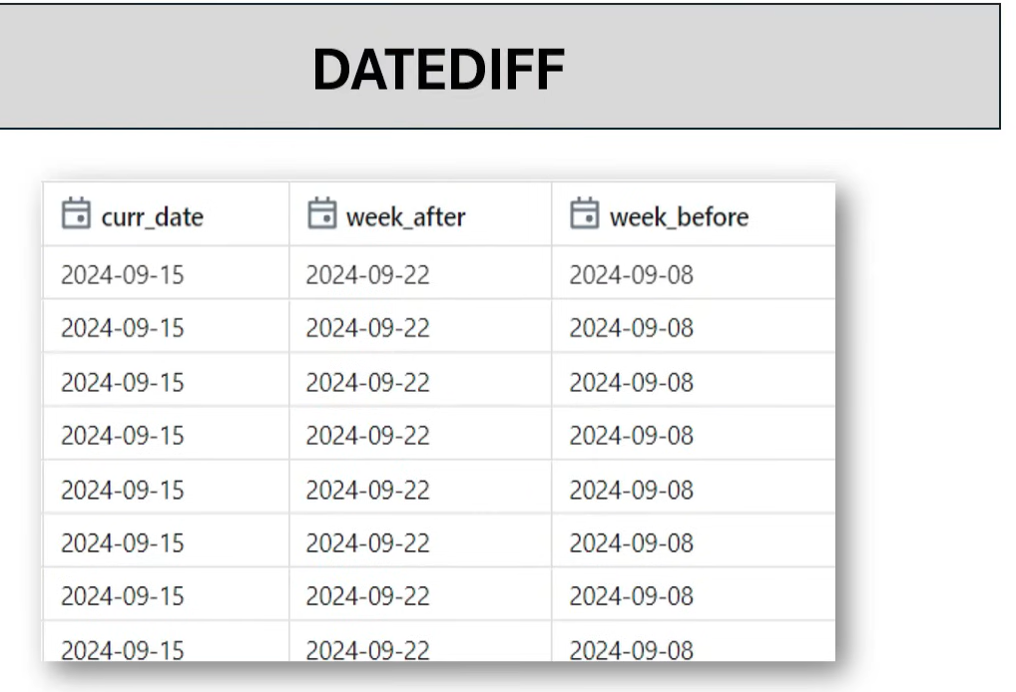

Date_diff=date_sub.withcolumn(‘datediff’,datediff(‘week_after’,curr_date))
Date_diff.display()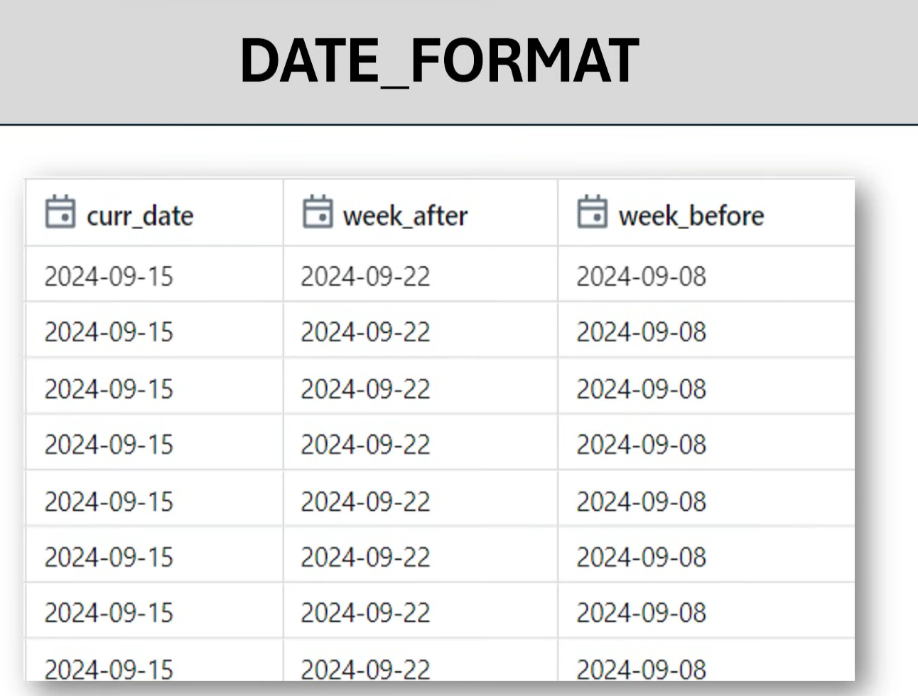
Date_diff.withcolumn(‘weekbefore’,date_format(‘week_before’,’dd-MM-yyyy’))
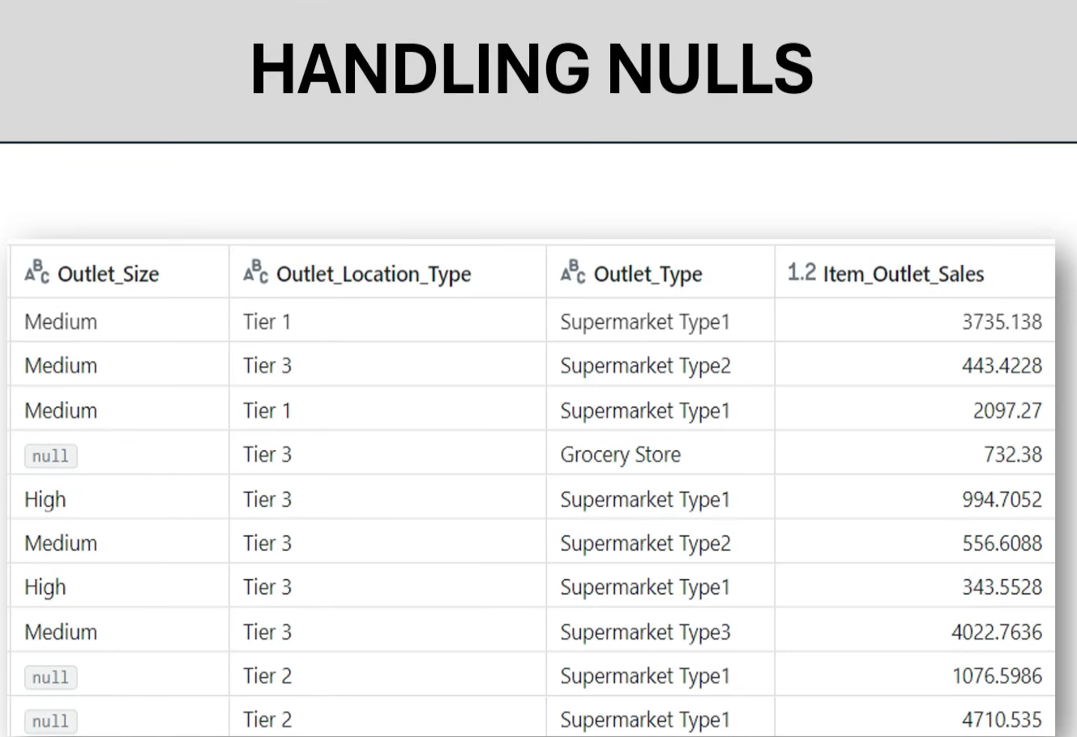
Df.dropna(‘all’).display()
Df.dropna(‘any’).display()
Df.dropna(subset=[‘Order_Size’]).display()
Df.fillna(‘notavailable’).display()
Df.fillna(‘notavailable’,subset=[‘Order_Size’]).display()
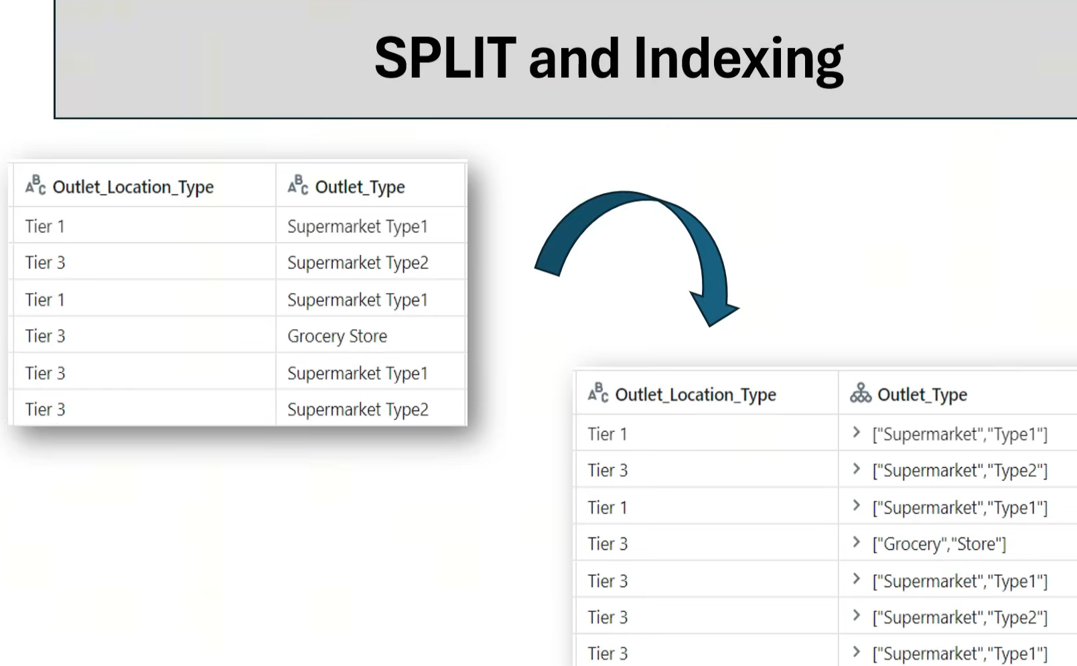
Df.withcolumn(‘Outlet_Type’,split(‘Outlet_Type’,’ ‘)).display()

Df.withcolumn(‘Outlet_Type’,split(‘Outlet_Type’,’ ‘)[1]).display()

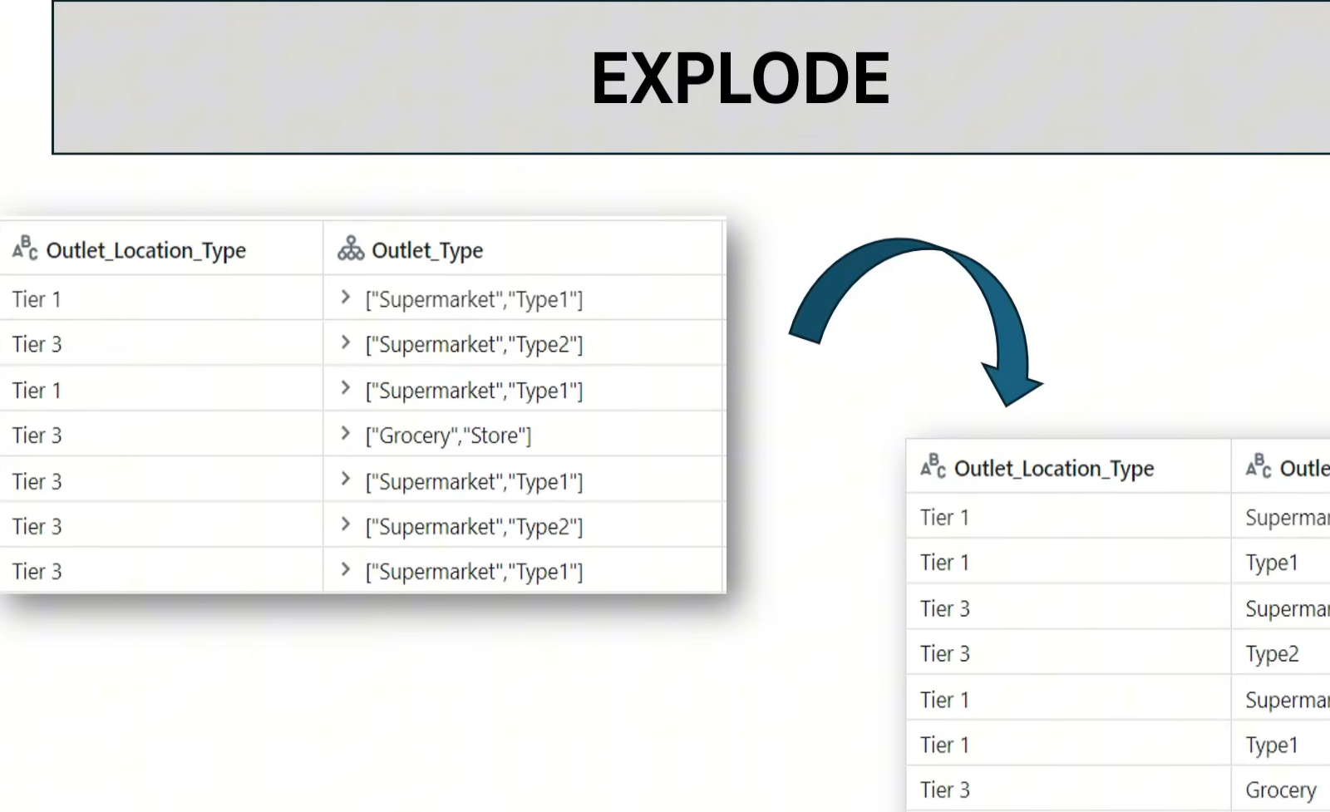
Df_exp = Df.withcolumn(‘Outlet_Type’,split(‘Outlet_Type’,’ ‘))
Df_exp.display()
Df_exp.withColumn(‘Outlet_Type’,explode(‘Outlet_Type’)).display()
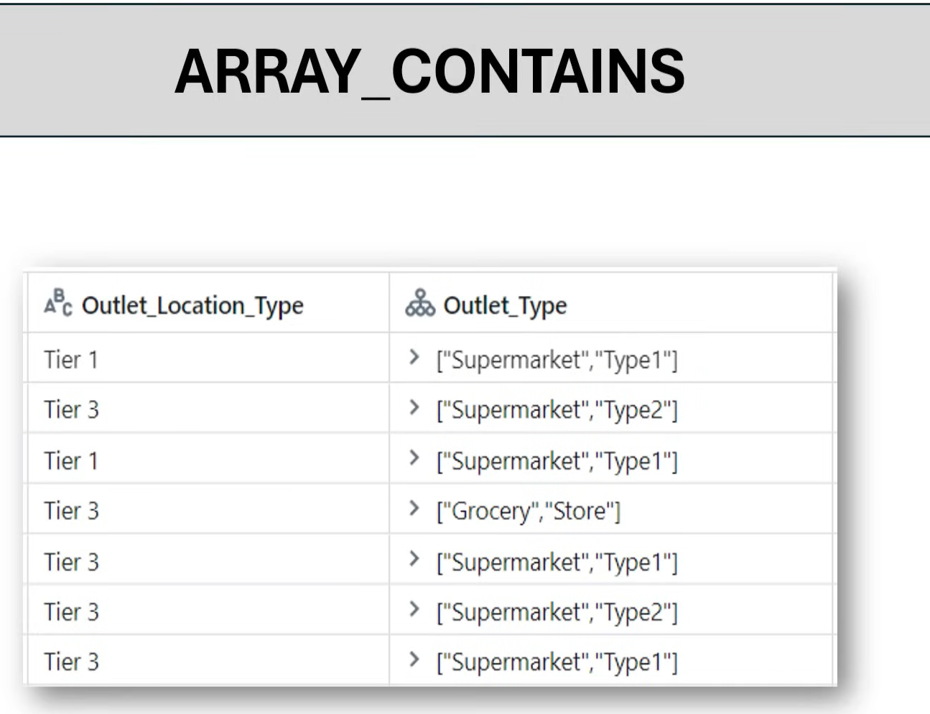
Df_exp.withcolumn(‘Type1_flag’,arraycontains(‘Outlet_Type’,’Type1’)).display()
Df.groupby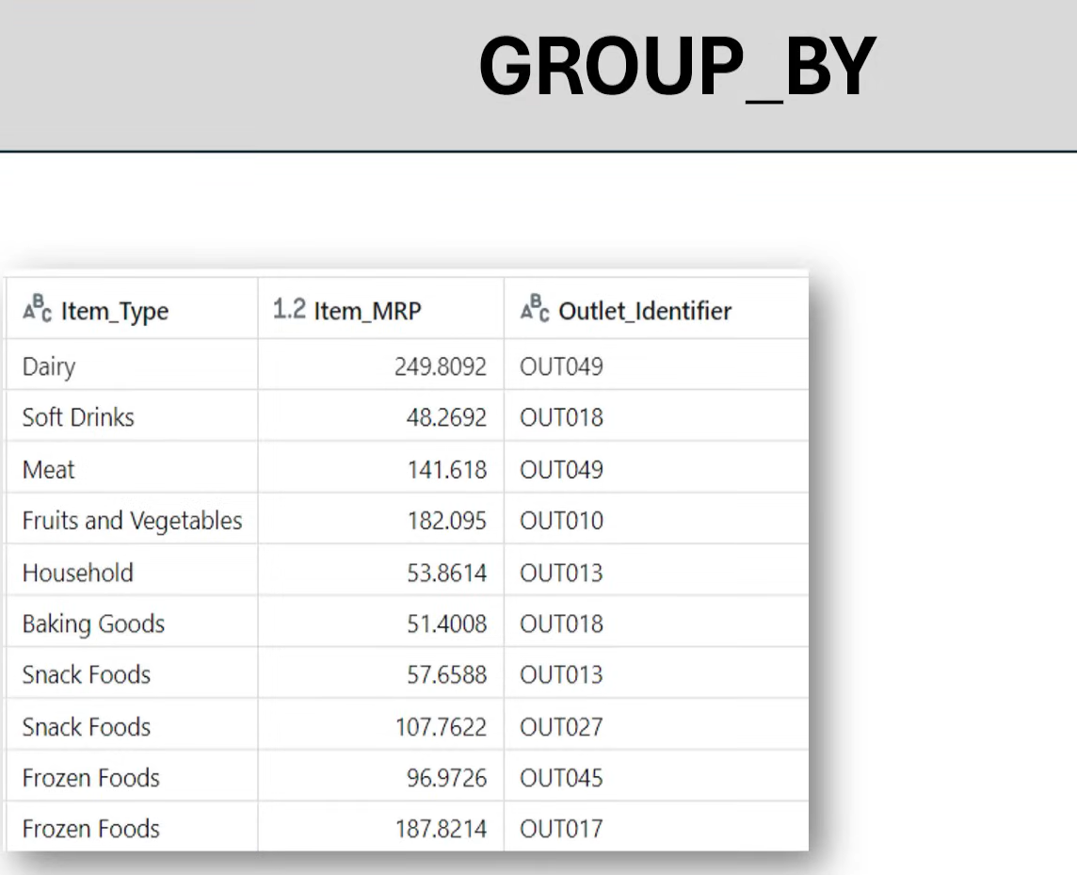
Df.groupby(‘Item_type’).agg(sum(‘Item_MRP’)).display()

Df.groupby(‘Item_type’).agg(avg(‘Item_MRP’)).display()
Df.groupby(‘Item_type’,’Outlet_size’).agg(avg(‘Item_MRP’).alias(‘Total MRP’)).display()
Df.groupby(‘Item_type’,’Outlet_size’).agg(sum(‘Item_MRP’,’avg(‘Item_MRP’).alias(‘Total MRP’)).display()
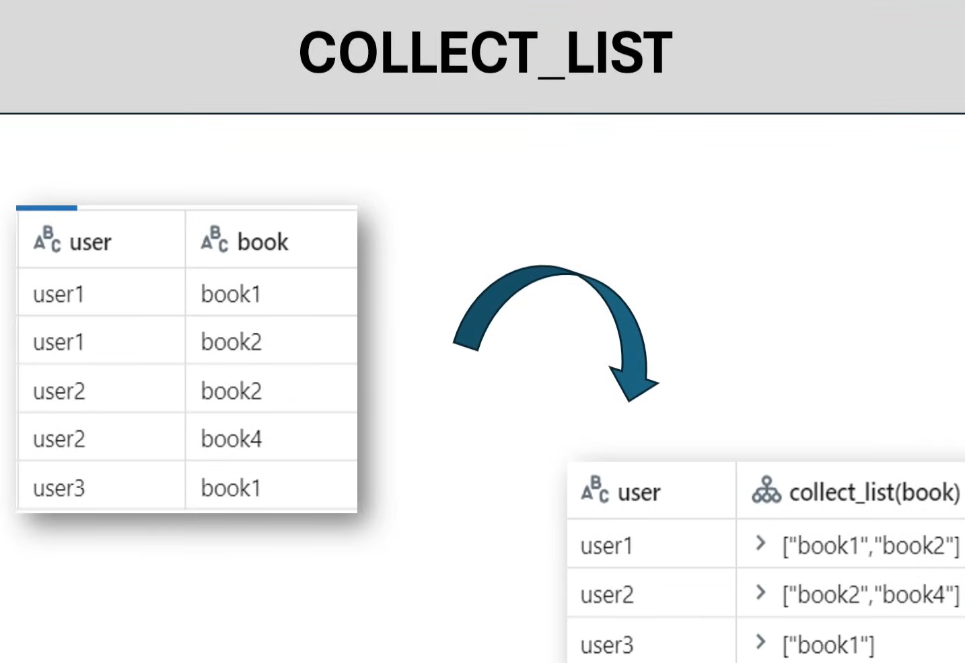
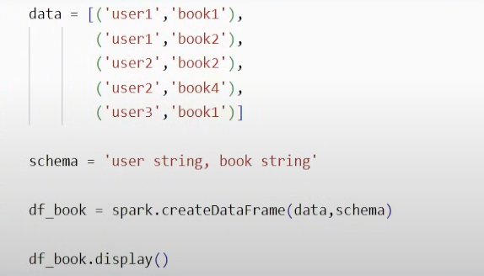
Df_book.groupby(‘user’).agg(collect_list(‘book’)).display()

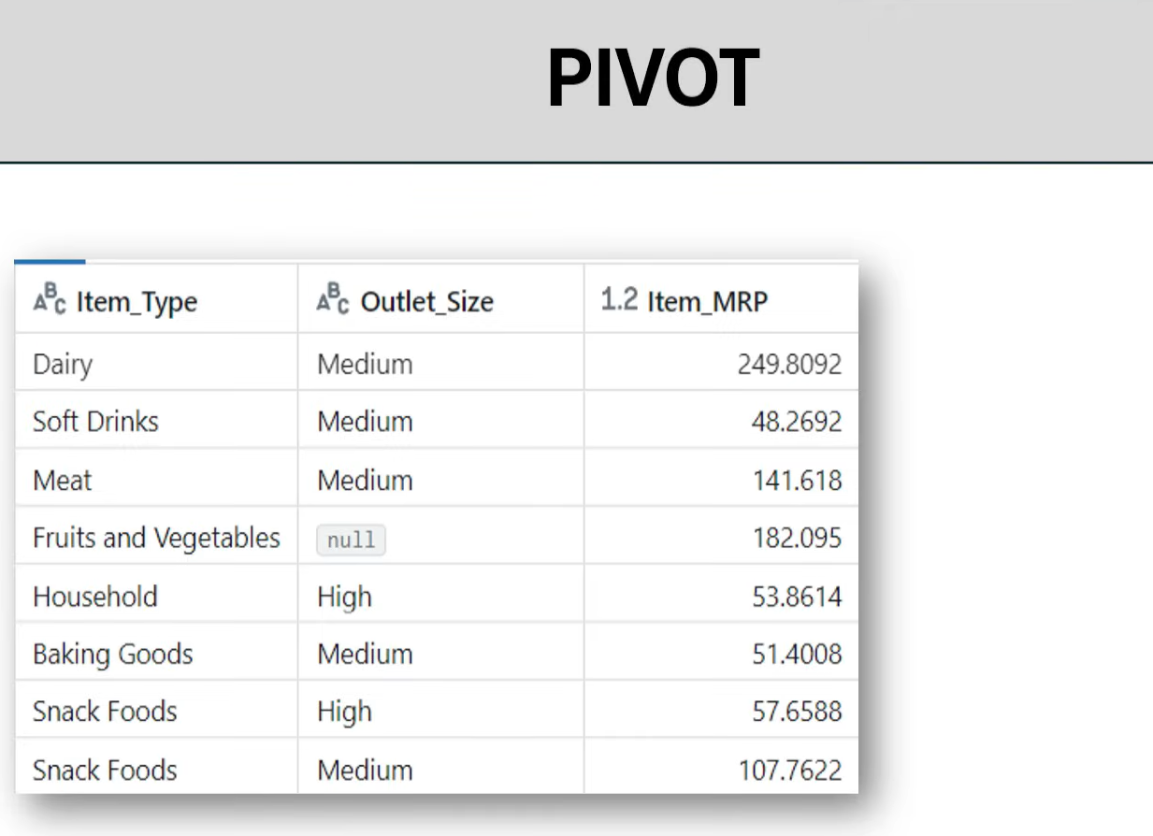
Df_book.groupby(‘Item_type’).pivot(‘Outlet_Size’).agg(avg(‘Item_MRP’)).display()
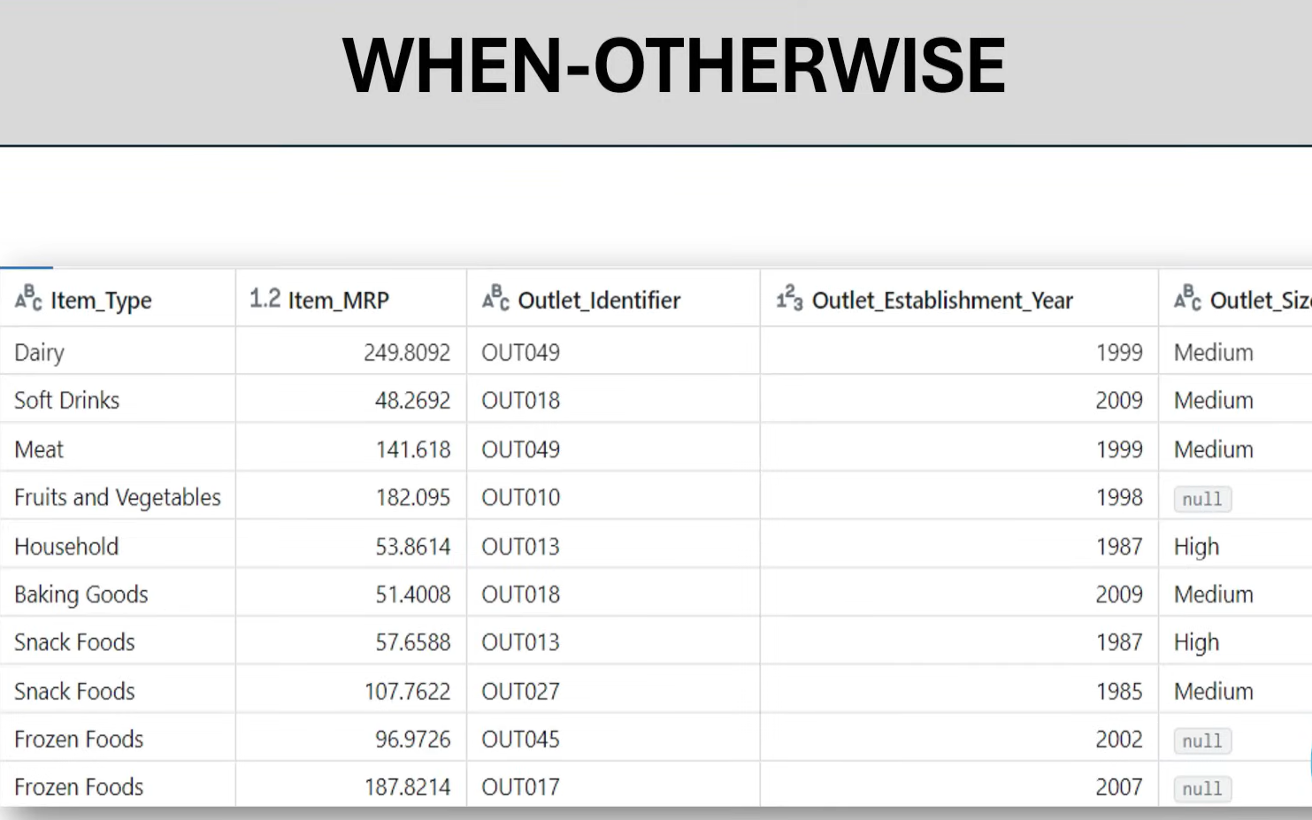
Df = Df.withcolumn(‘veg_flag’, when(col(‘Item_type’)==’Meat’,’Non-veg’).otherwise(‘Veg’)).display()


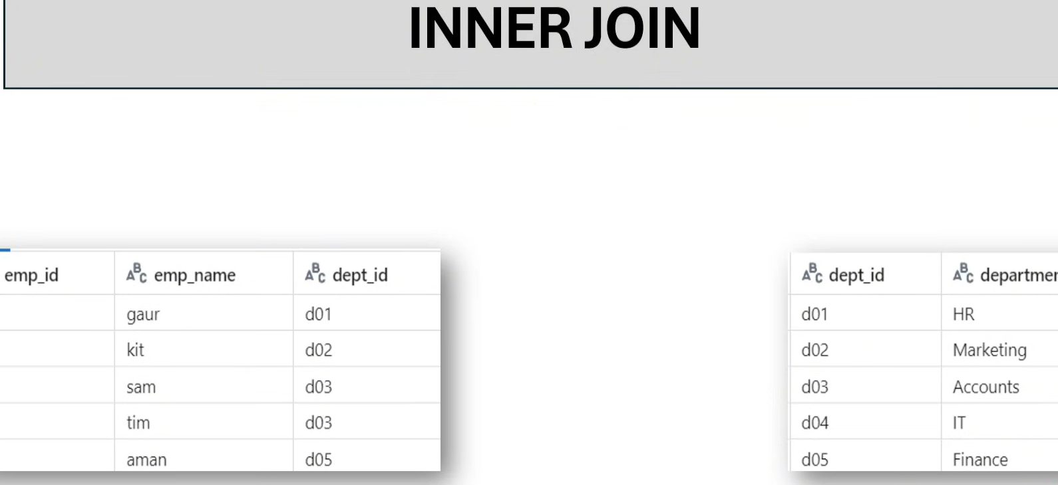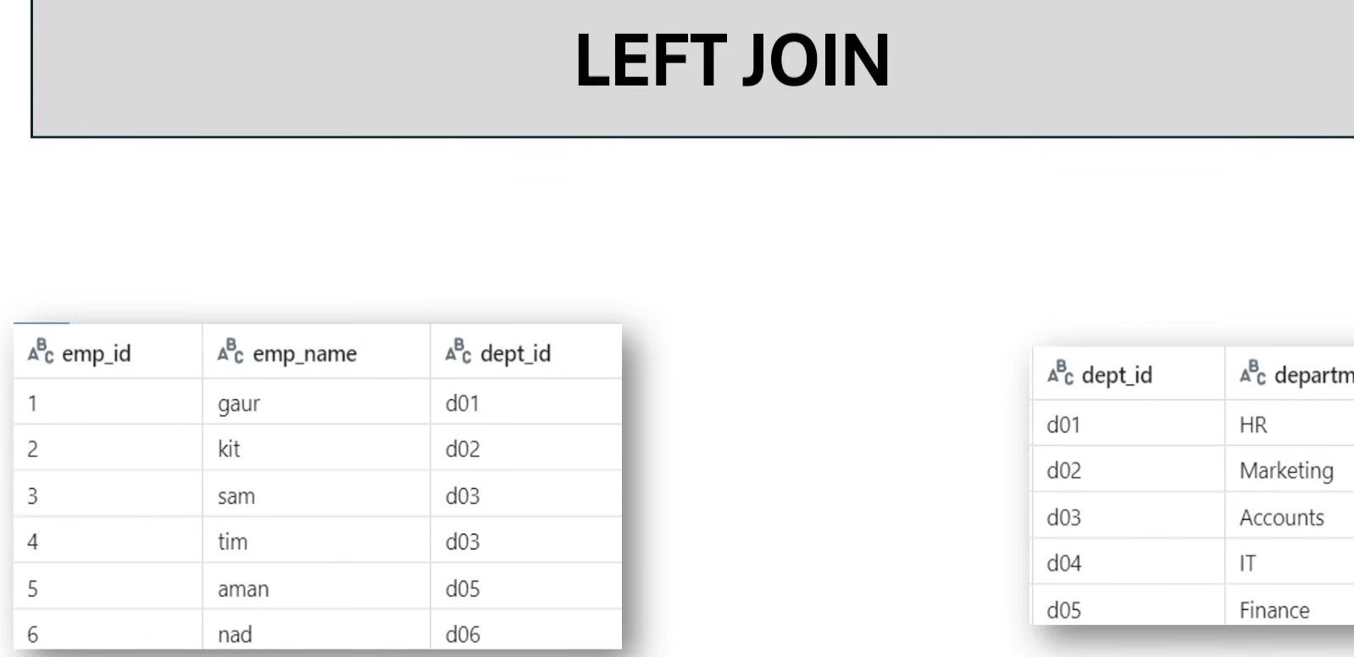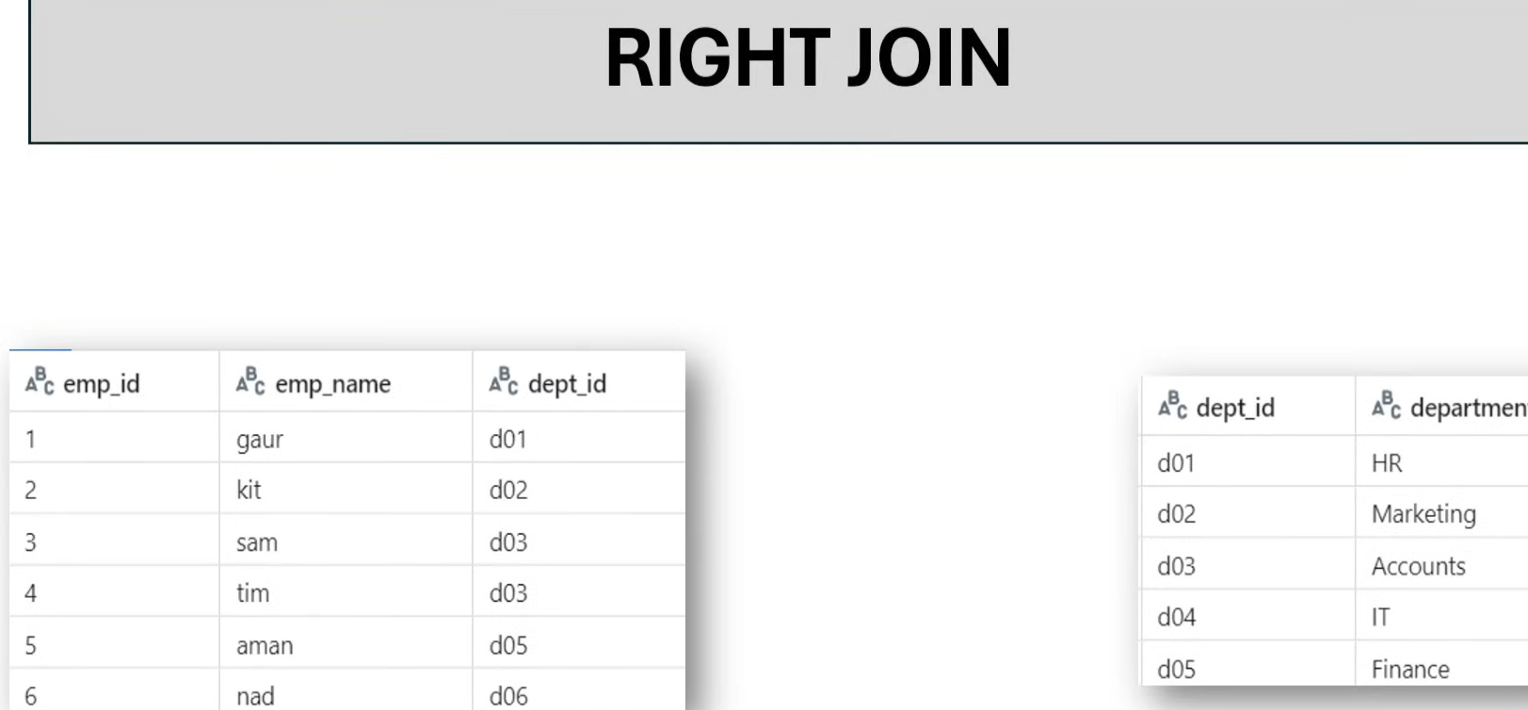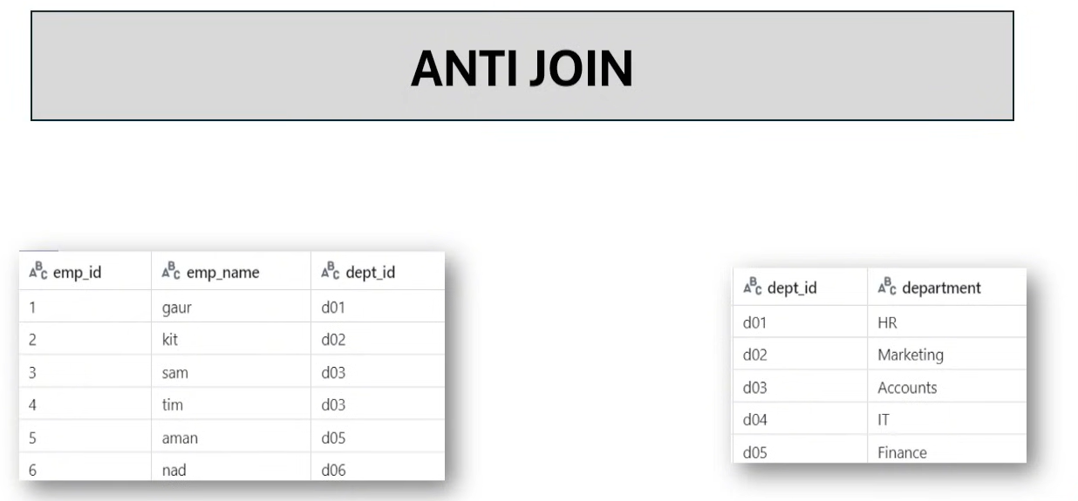
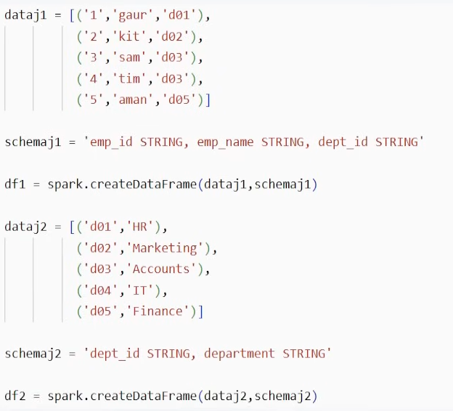
Df1.join(df2, df1[‘dept_id’]==df2[‘dept_id’],’inner’).display()
INNER JOIN
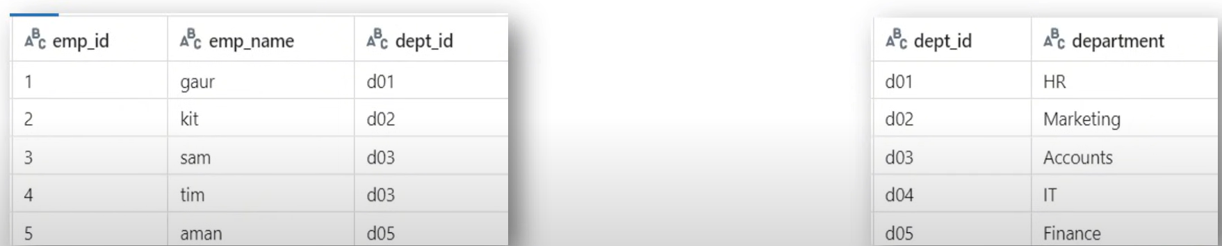
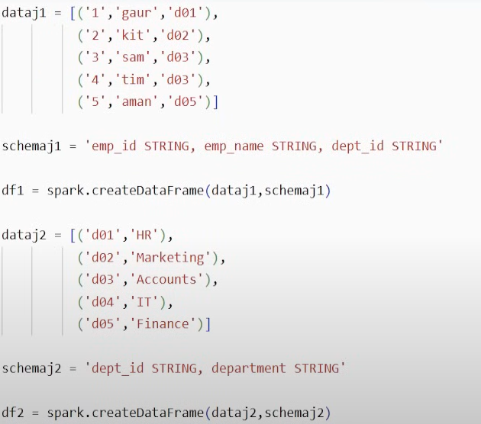
Df1.join(df2,df1[‘dept_id’]==df2[dept_id],’inner’).display()
LEFT JOIN
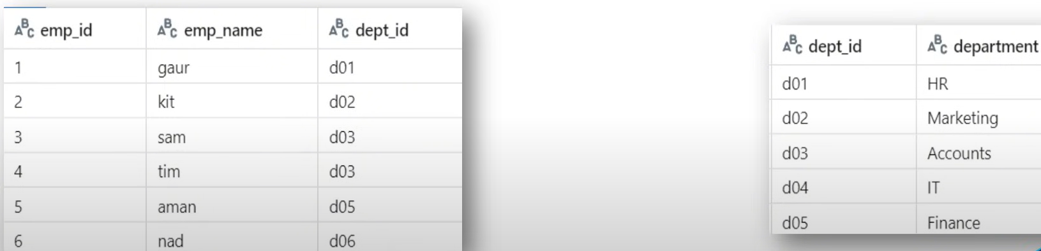
Df1.join(df2,df1[‘dept_id’]==df2[dept_id],’left’).display()

RIGHT JOIN
Df1.join(df2,df1[‘dept_id’]==df2[dept_id],’right’).display()

